**Lab - Monitor and Manage System Resources in Windows**

Instructions

## Starting and Stopping the Routing and Remote Access service

* + 1. Navigate to the **Control Panel** > Click **Network and Sharing Center**.

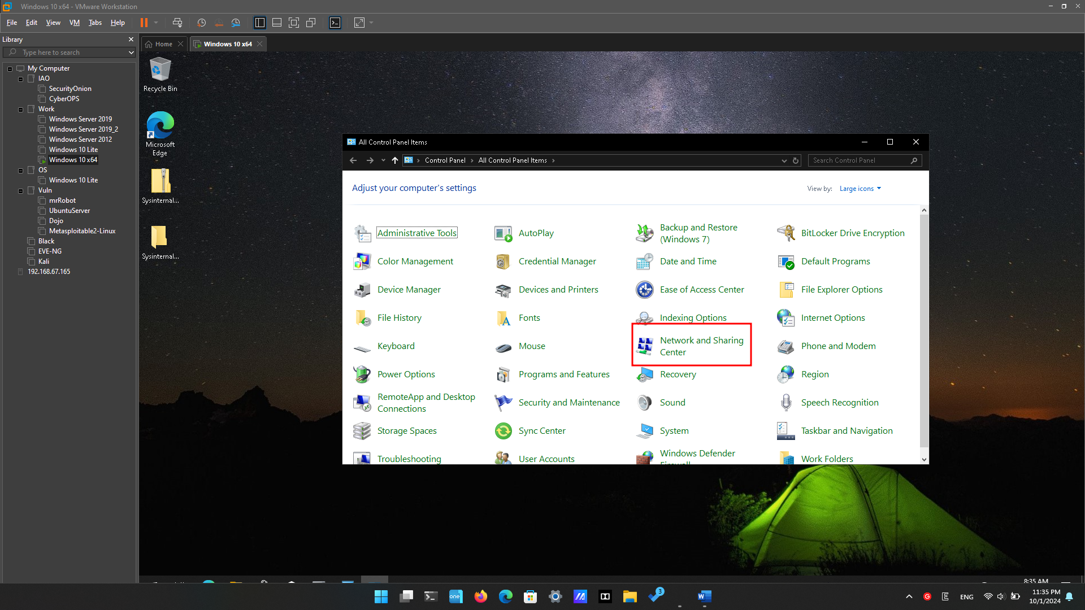

* + 1. Click **Change adapter settings** in the left pane. Reduce the size of the **Network Connections** window and leave it open.

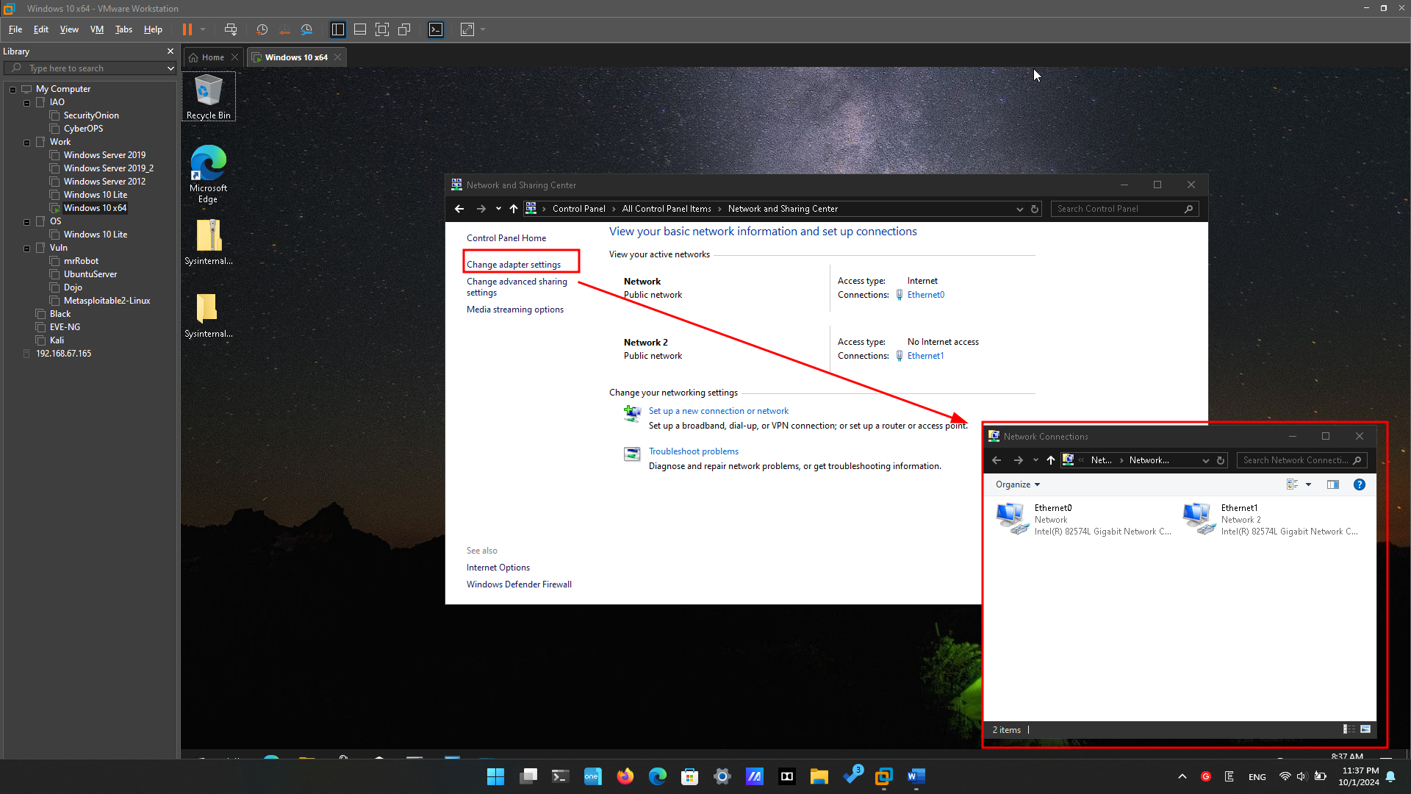

* + 1. Navigate to the **Administrative Tools**. (Navigate to the **Control Panel** > Click **Administrative Tools**)

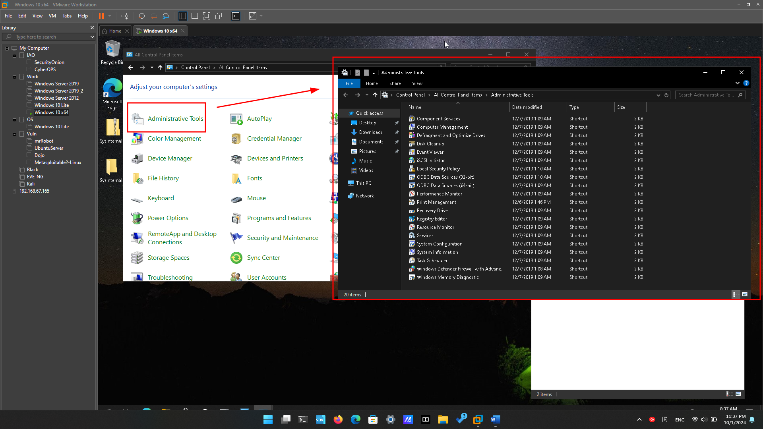

* + 1. In the **Administrative Tools** window, double-click the **Performance Monitor** icon.

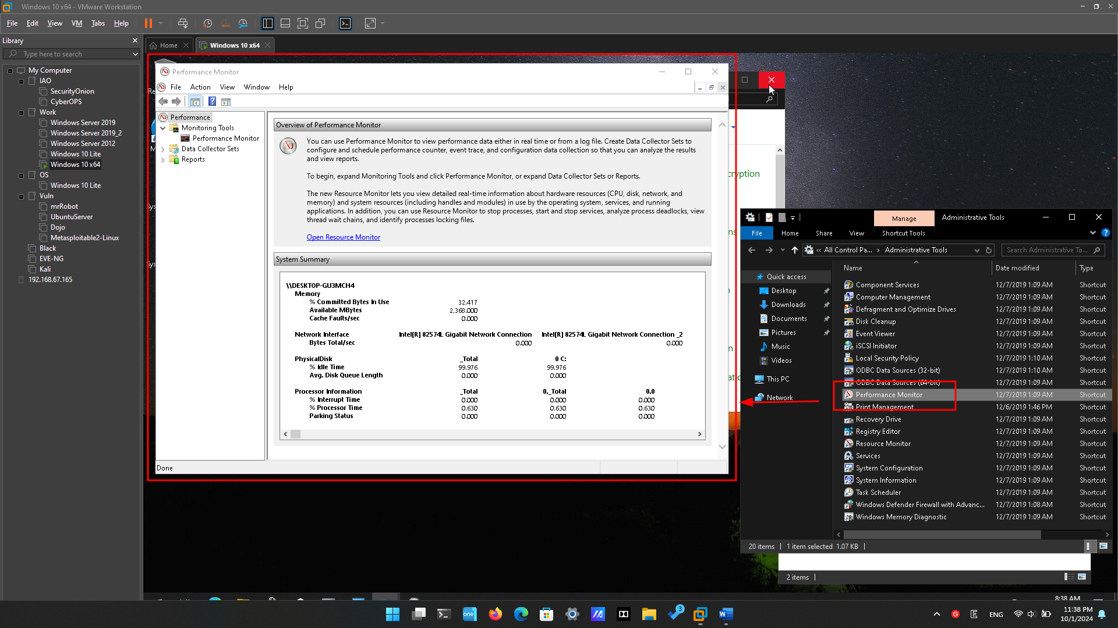

* + 1. In the **Performance Monitor** window, make sure **Performance Monitor** under Monitoring Tool heading in the left pane is highlighted. Click the **Freeze Display** icon (pause button) to stop the recording.

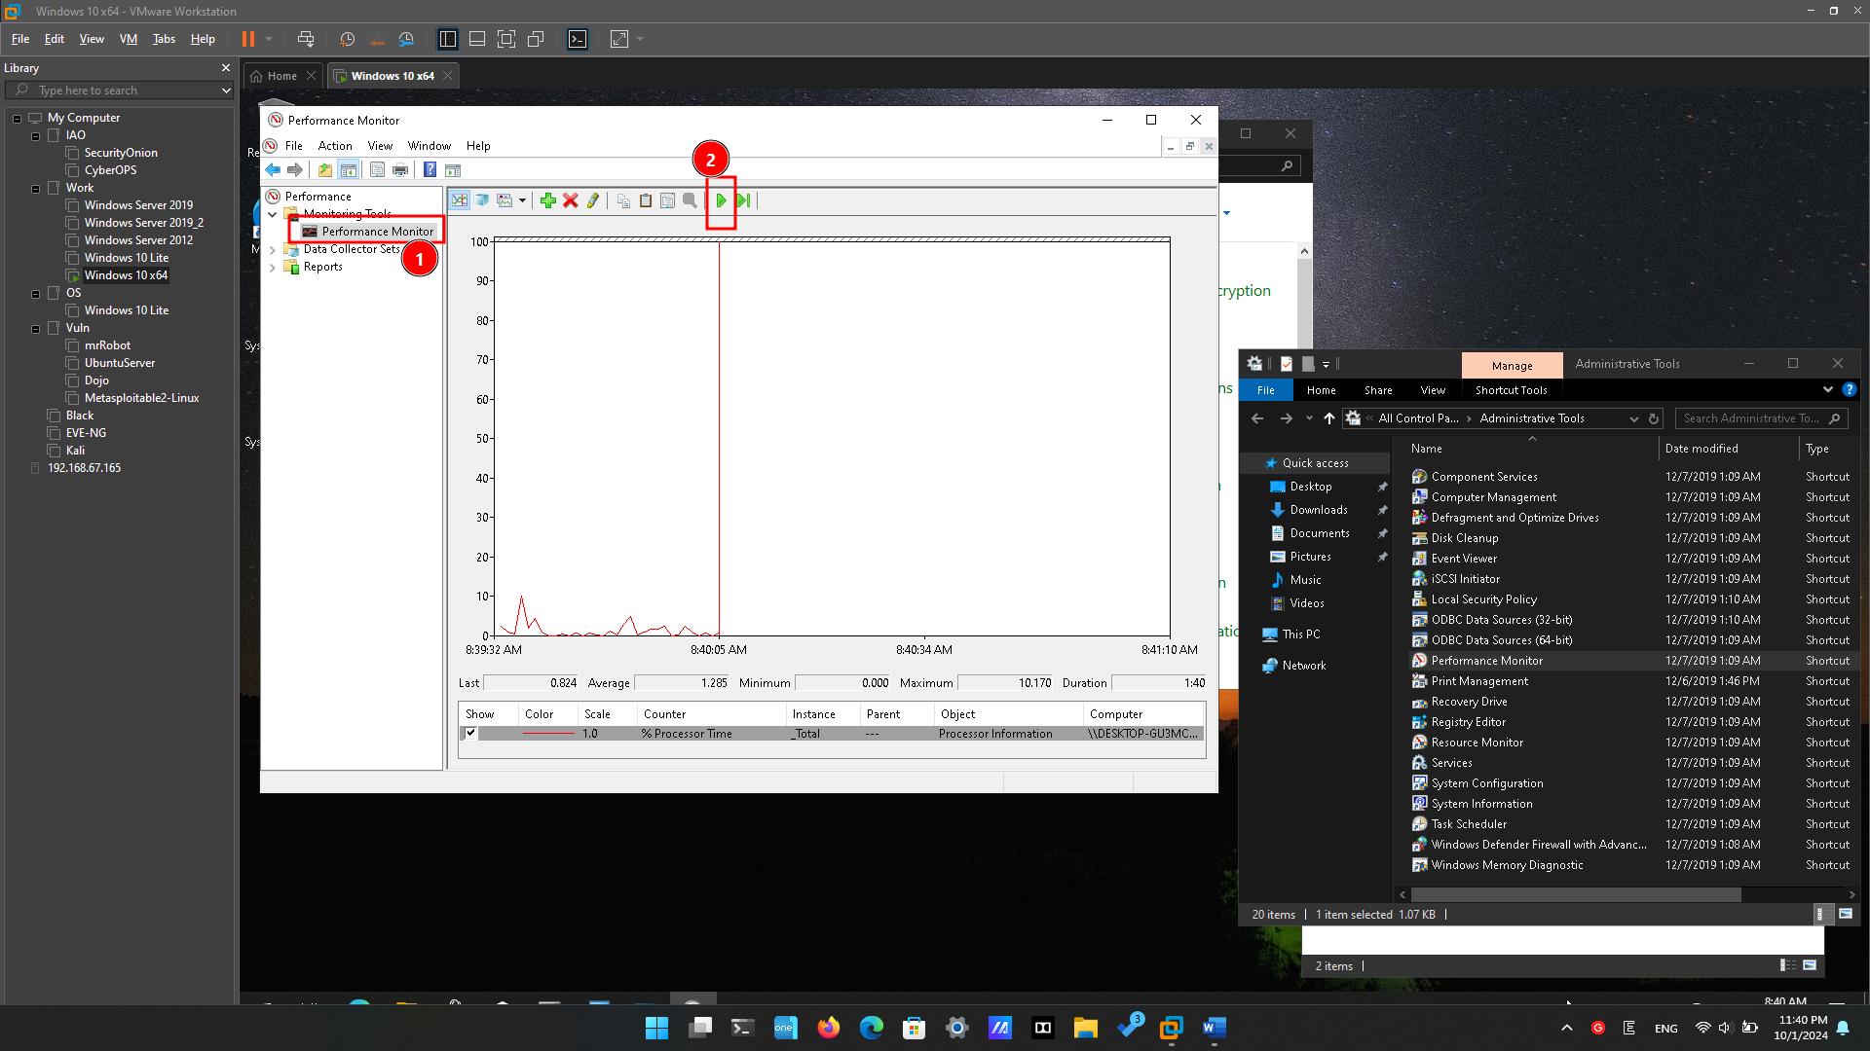

* + 1. Right-click the graph and select **Clear** to clear the graph. Leave this window open.

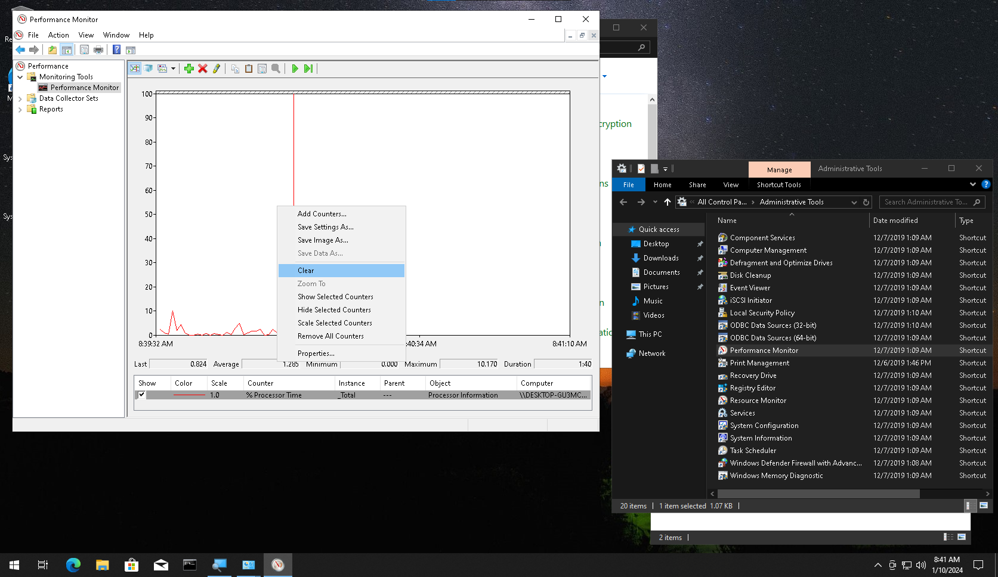

* + 1. Navigate to the **Administrative Tools** and select **Services**.

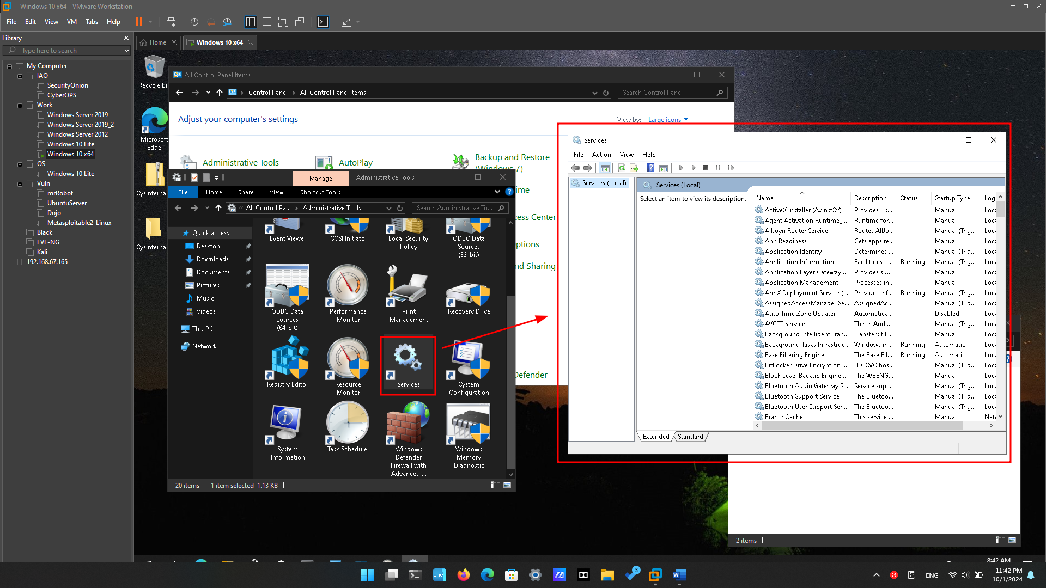

* + 1. Expand the width of the **Services** window so you have a clear view of the content. Scroll down in the right pane until you see the service **Routing and Remote Access**. Double-click **Routing and Remote Access**.

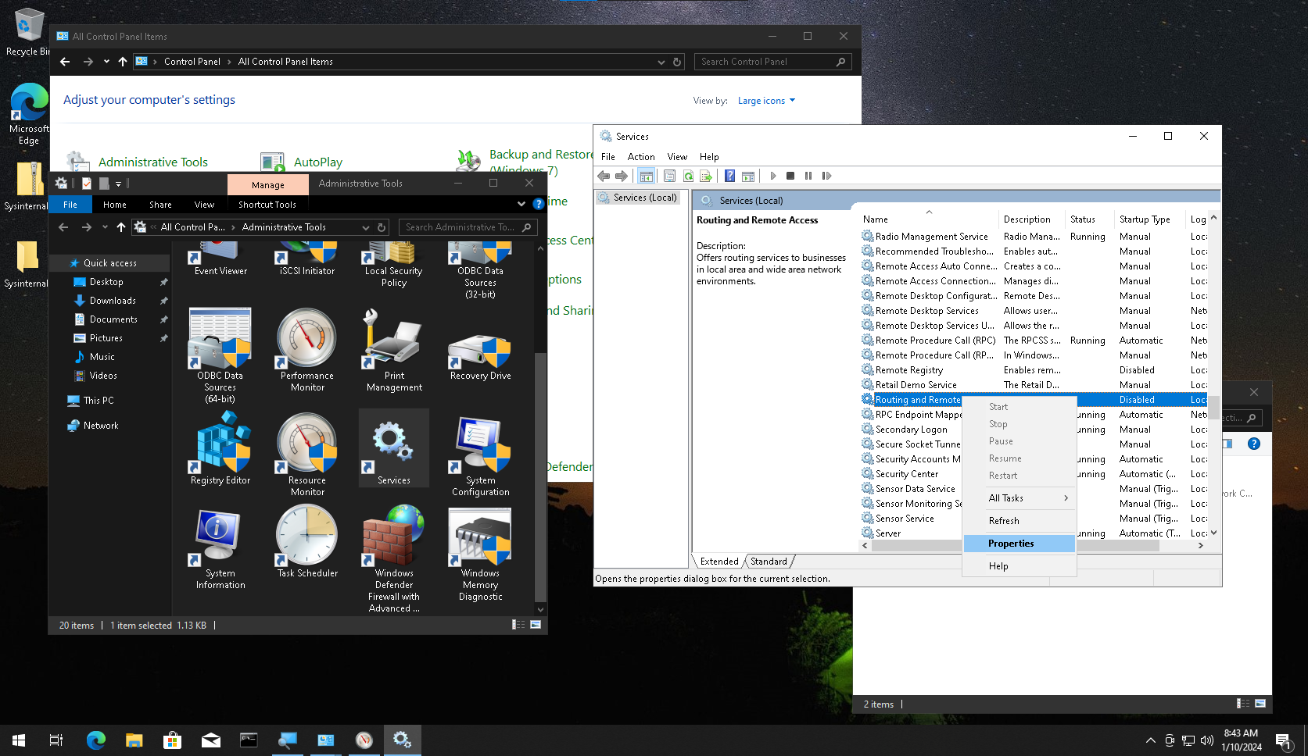

* + 1. In the **Routing and Remote Access Properties (Local Computer)** window opens. In the **Startup type** drop-down field, select **Manual** and then click **Apply**.

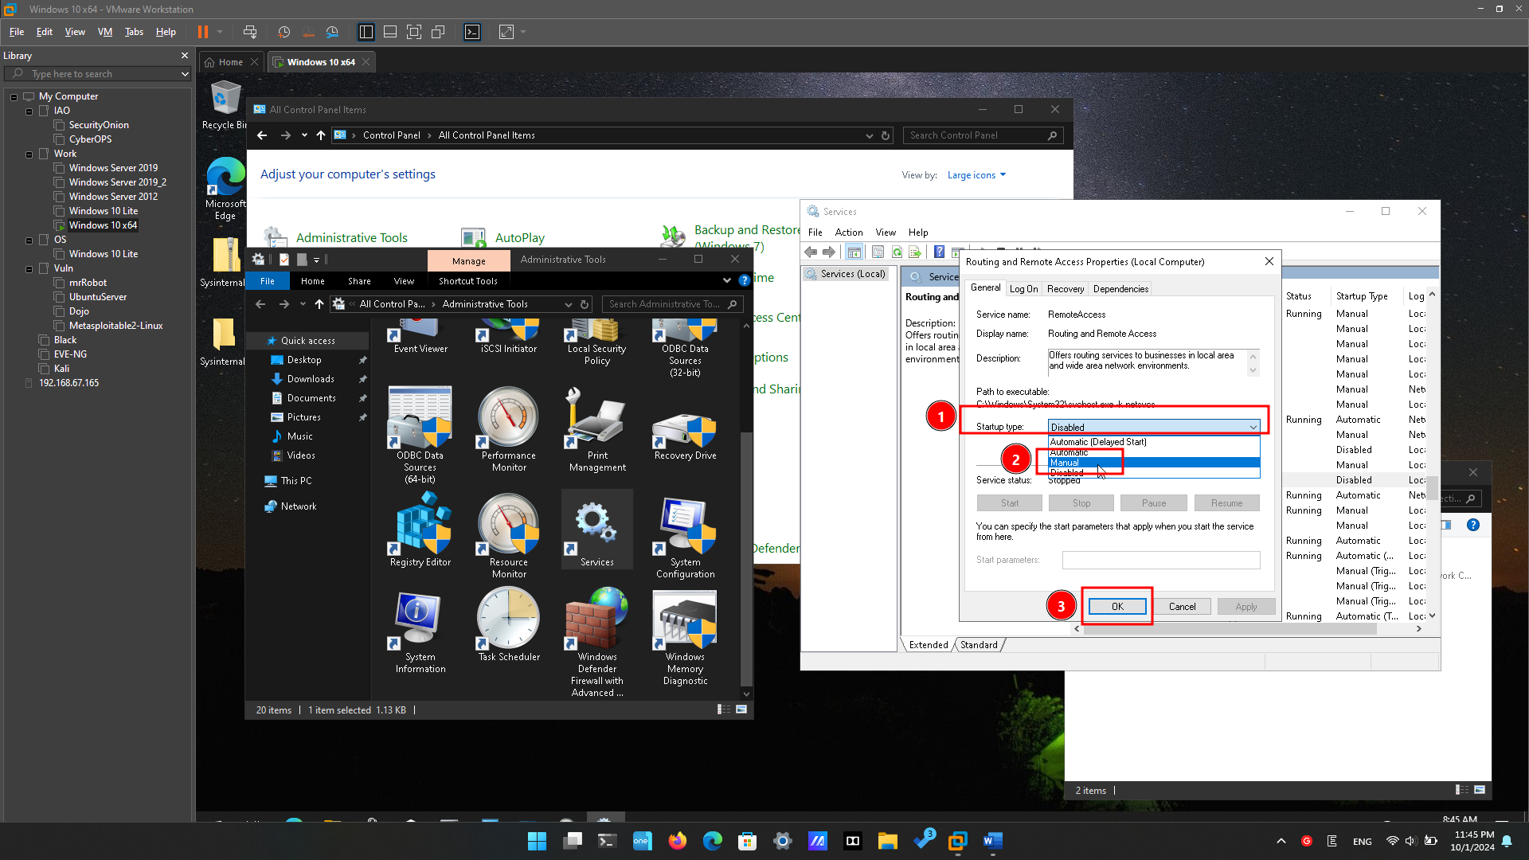

* + 1. Navigate to **Performance Monitor** window. Click the **Unfreeze Display** icon to start the recording.
    2. Click the **Routing and Remote Access Properties (Local Computer)** window. To start the service, click **Start**. A window with a progress bar opens.

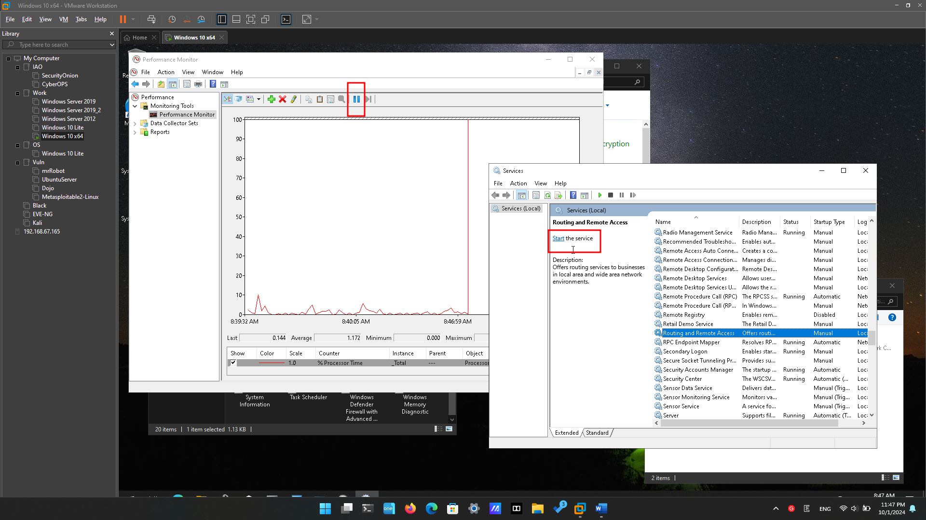

* + 1. The **Routing and Remote Access Properties (Local Computer)** window now shows the Stop and Pause button active. Leave this window open.
    2. Navigate to **Network Connections** window. Press the function key **F5** to refresh the content.

### Question:

What changes appear in the window after starting the **Routing and Remote Access** service?

A new Connection: “Incoming Connection” appear.

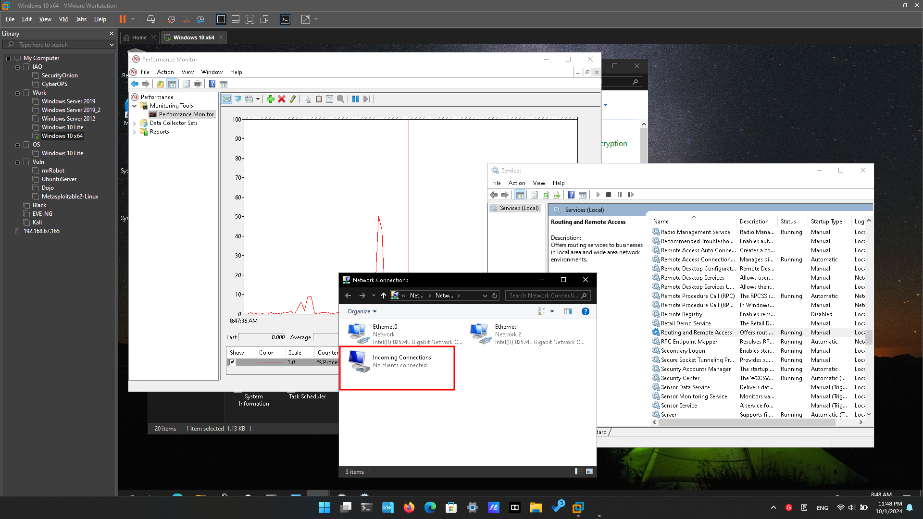

* + 1. Navigate to **Routing and Remote Access Properties (Local Computer)** window and click **Stop**. **Note**: If **Stop** is greyed out, click **Apply** and change the service status.

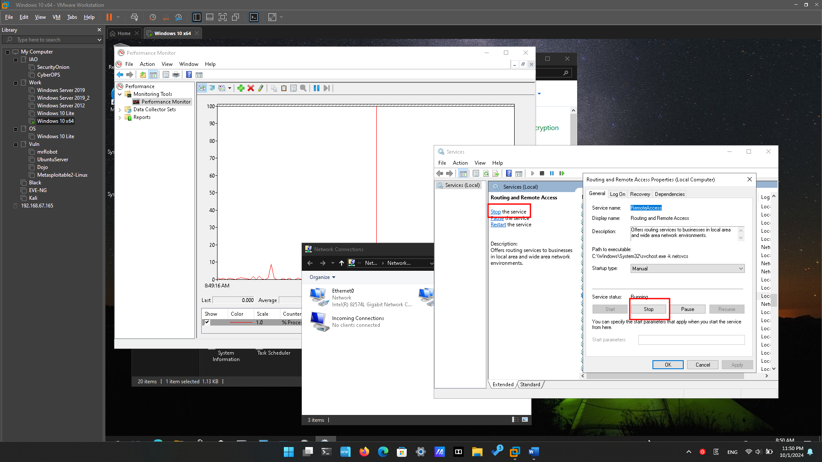

What are the descriptions for each of the four events?

“The start type of the Routing and Remote Access service was changed from demand start to disabled.”

* + 1. Navigate to **Network Connections** window.

### Question:

What changes appear in the right pane after stopping the Routing and Remote Access service?

The “Incoming Connections”is no longer displayed.

* + 1. Navigate to **Performance Monitor** window and click the **Freeze Display** icon to stop the recording.
    2. Click the **Change graph type** drop-down menu, select **Report**.
    3. The display changes to report view.

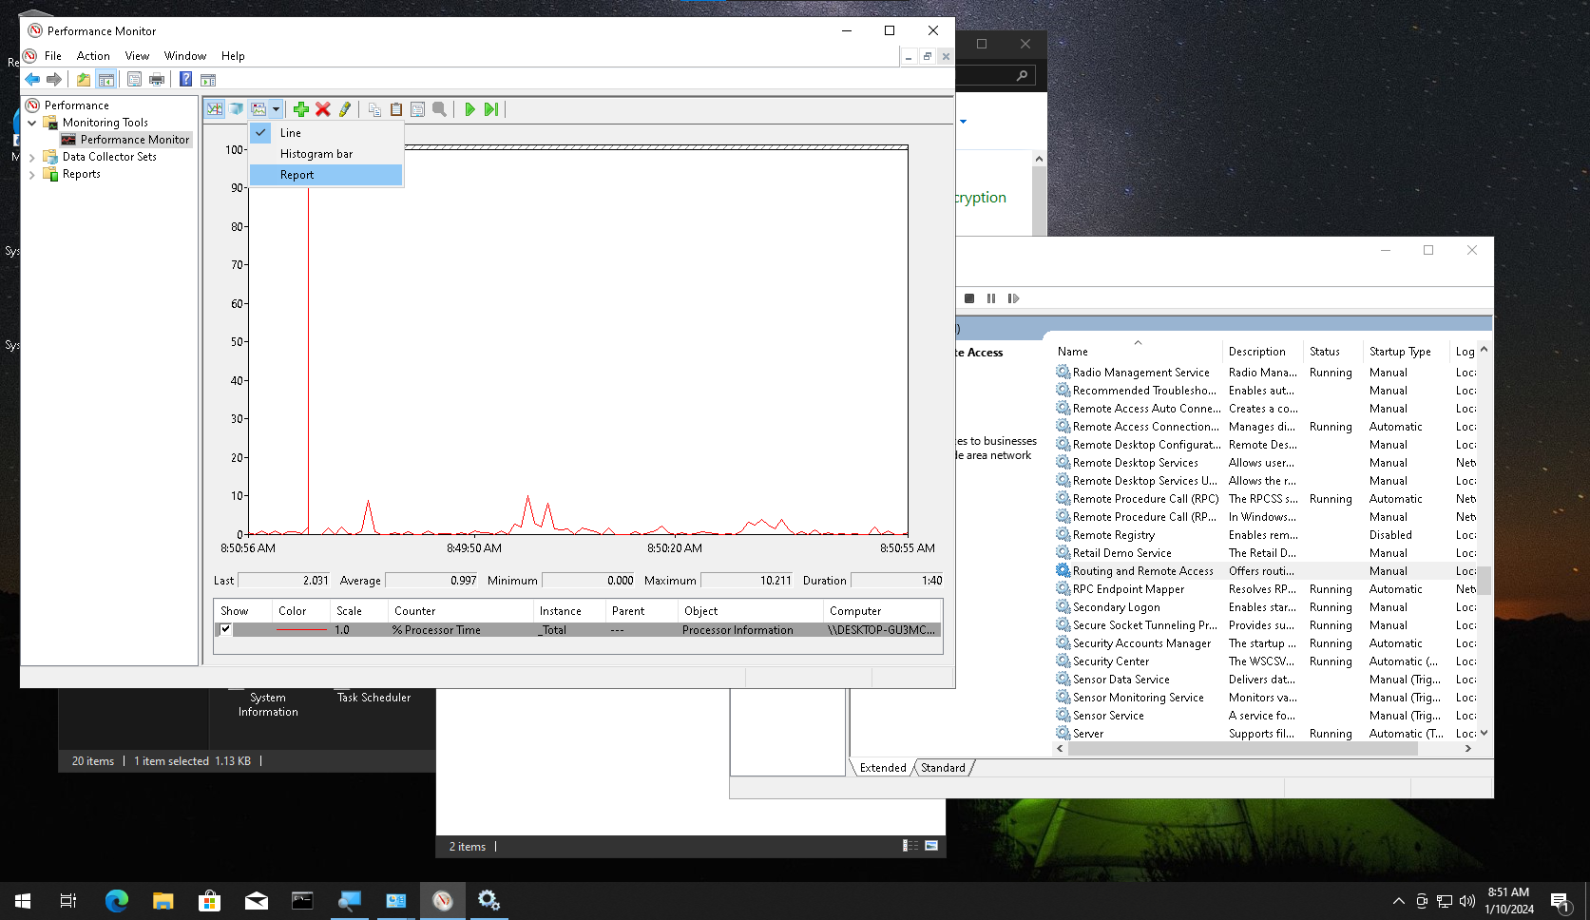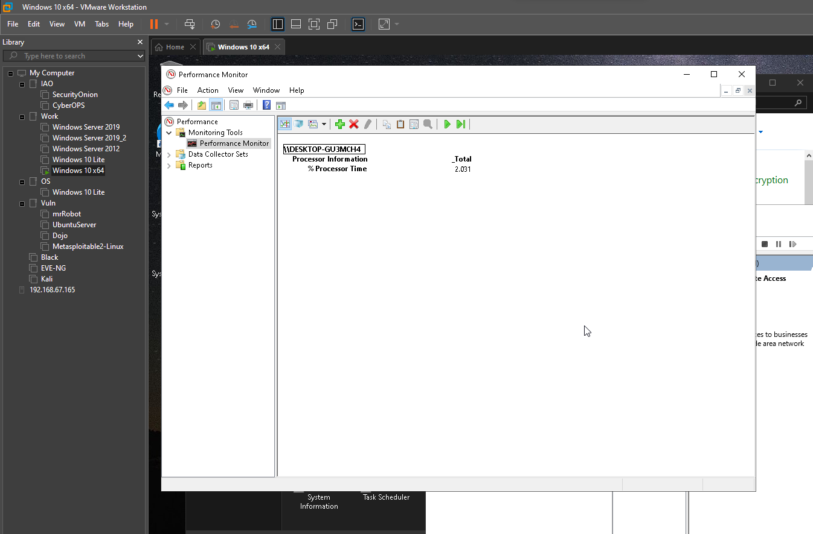

* + 1. Click the **Routing and Remote Access Properties (Local Computer)** window. In the Startup type field, select **Disabled** and click **OK**.

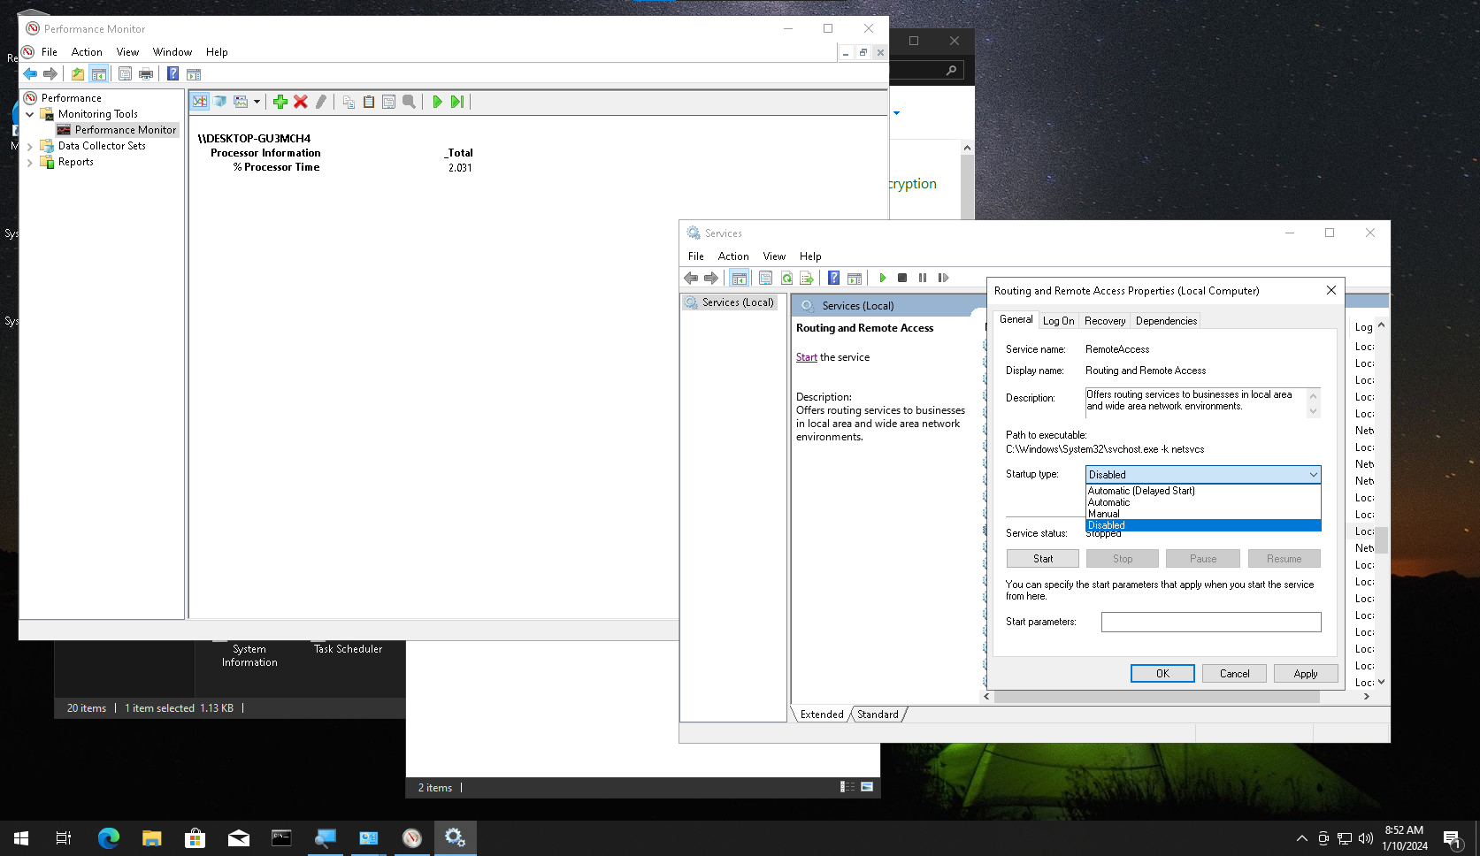

* + 1. Click the **Services** window.

### Question:

What is the Status and Startup Type for Routing and Remote Access?

Status: Stopped

Startup Type: Disable

* + 1. Click the **Performance Monitor** window. Click the **Unfreeze Display** icon to start the recording.
    2. Close all open windows you opened during Step 1 of this lab.

## Working in the Computer Management Utility

* + 1. Click **Control Panel** > **Administrative Tools**. Select **Computer Management**.

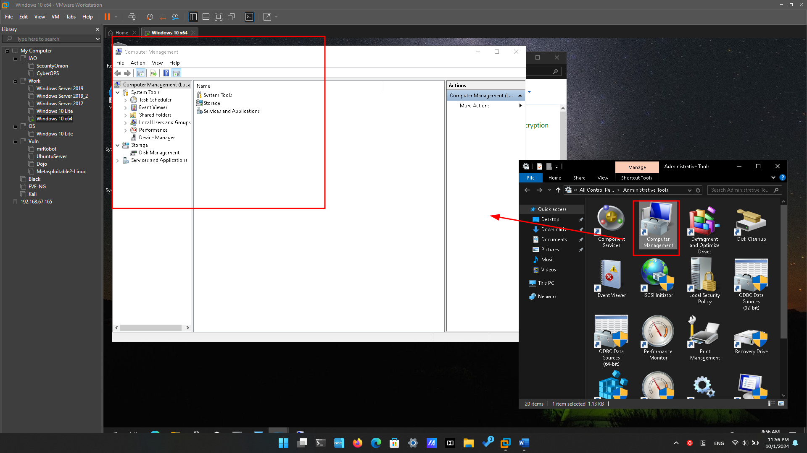

* + 1. In the **Computer Management** window, expand the three categories by clicking on the **arrow** next to **System Tools**.
    2. Click the arrow next to **Event Viewer** then click the arrownext to **Windows Logs**. Select **System**.

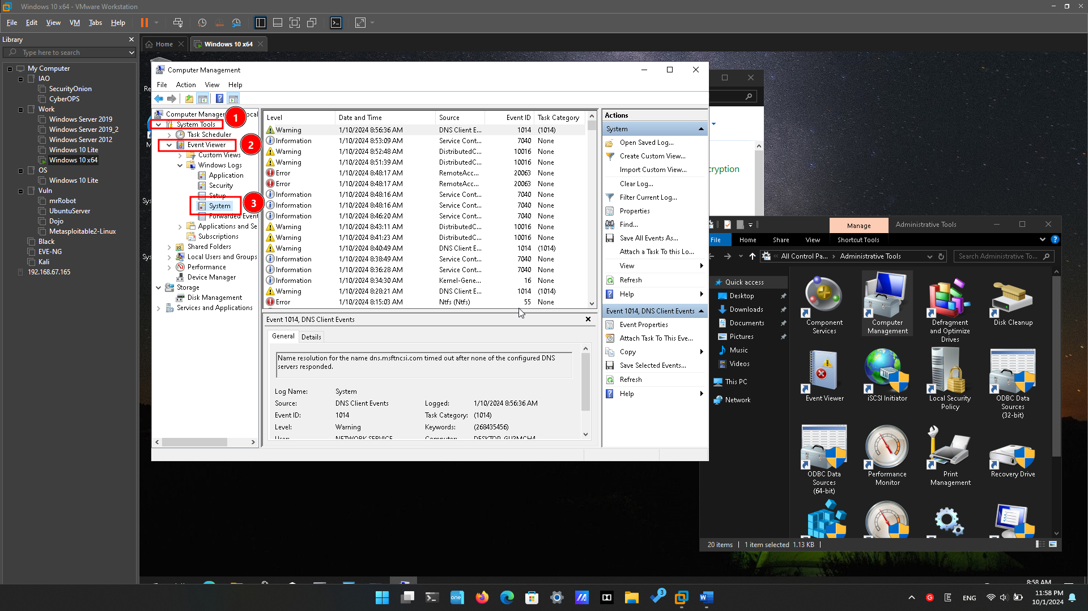

* + 1. The **Event Properties** window opens for the first event. Click the **down arrow** key to locate an event for **Routing and Remote Access**. You should find four events that describe the order for starting and stopping the **Routing and Remote Access** service.

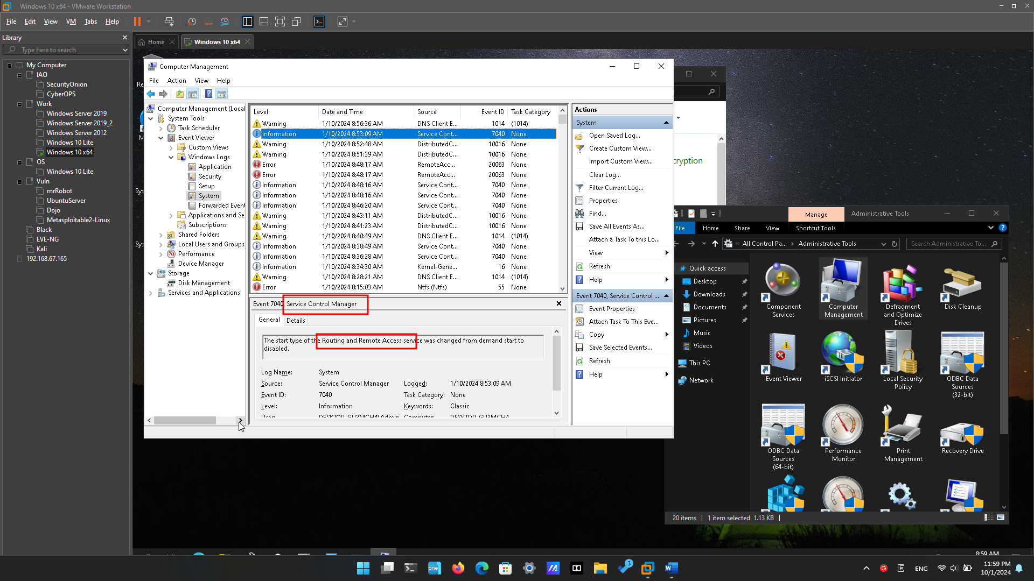

* + 1. Close all open windows.

## Configuring Administrative Tools

* + 1. Click **Control Panel** > **Administrative Tools** > **Performance Monitor**. The Performance Monitor window opens. Expand **Data Collector Sets**. Right-click **User Defined**, and select **New** > **Data Collector Set**.

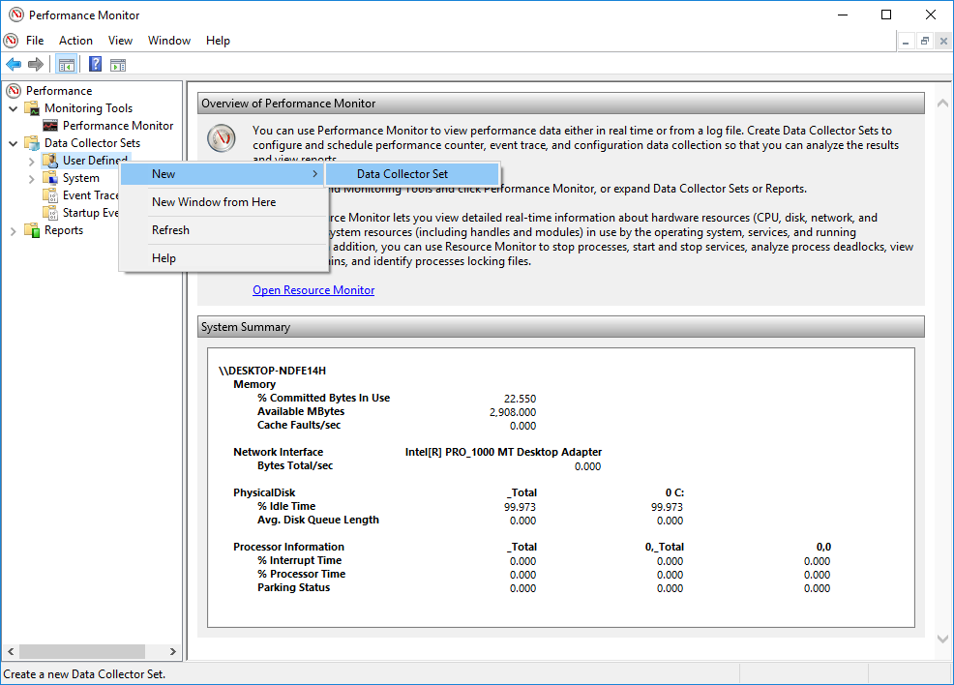

* + 1. The **Create new Data Collector Set** window opens. In the Name field, type **Memory Logs**. Select the **Create manually (Advanced)** radio button, and click **Next**.

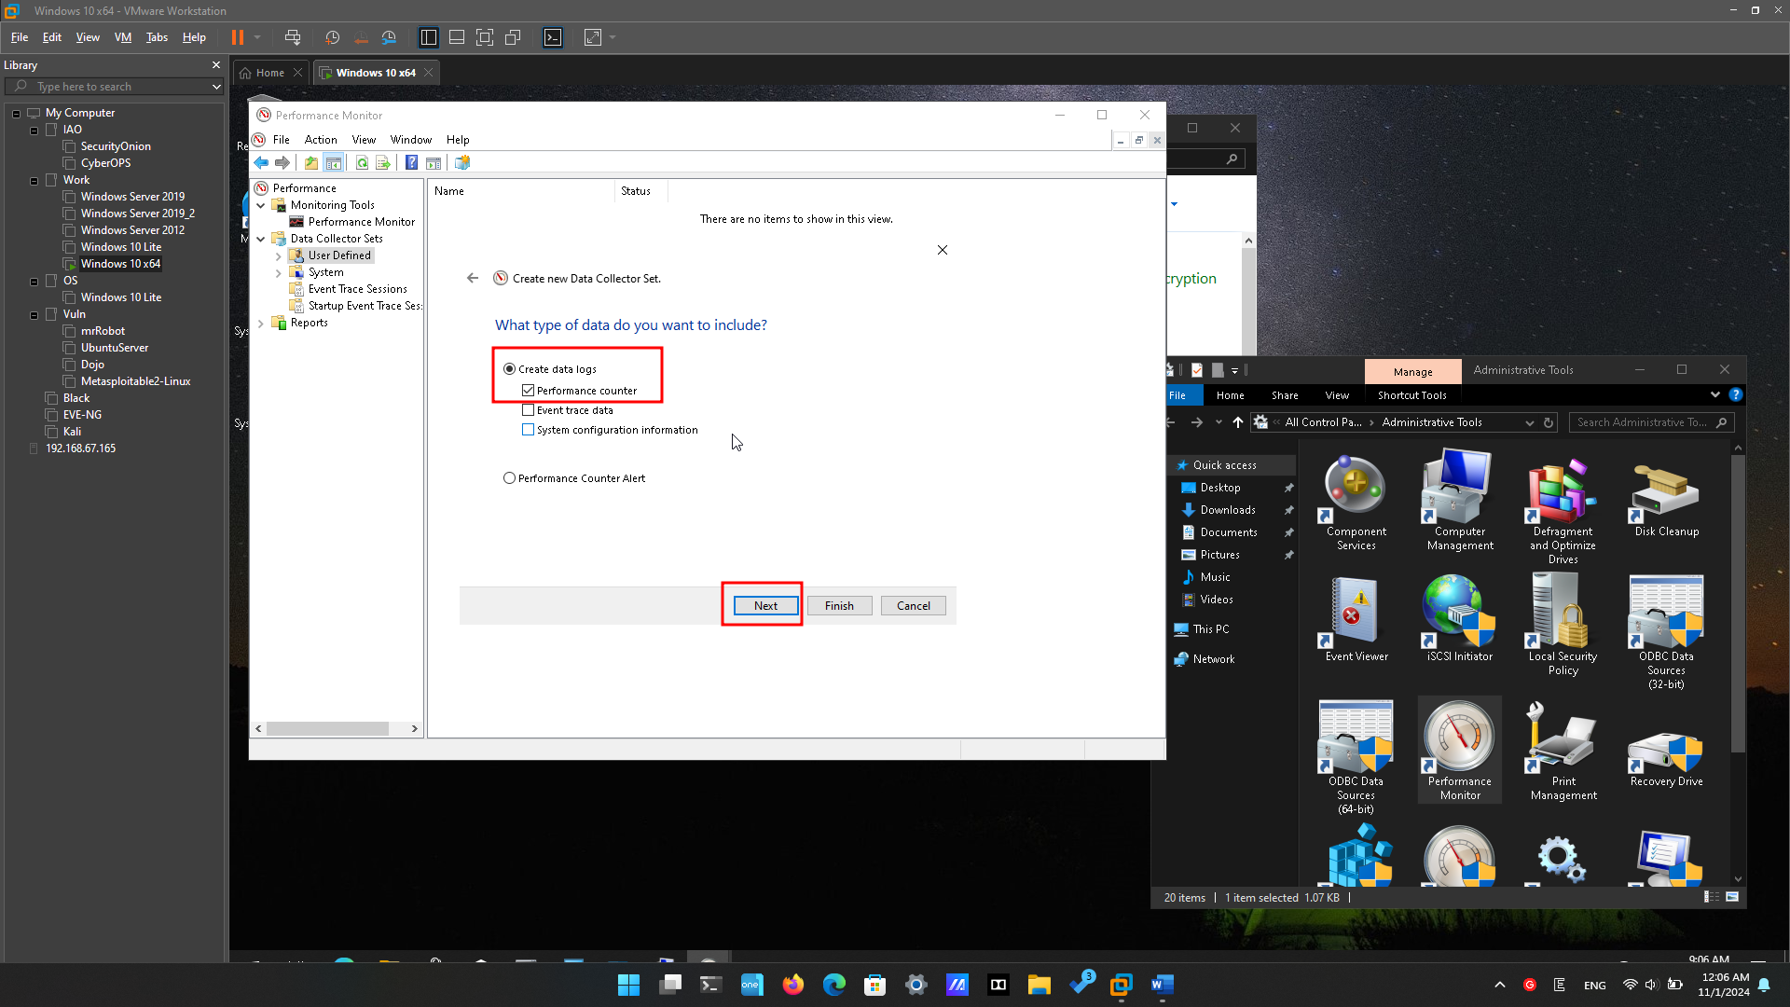

* + 1. In the **What type of data do you want to include?** window, check the **Performance counter** box then click **Next**.



* + 1. In the **Which performance counters would you like to log?** window, click **Add**.

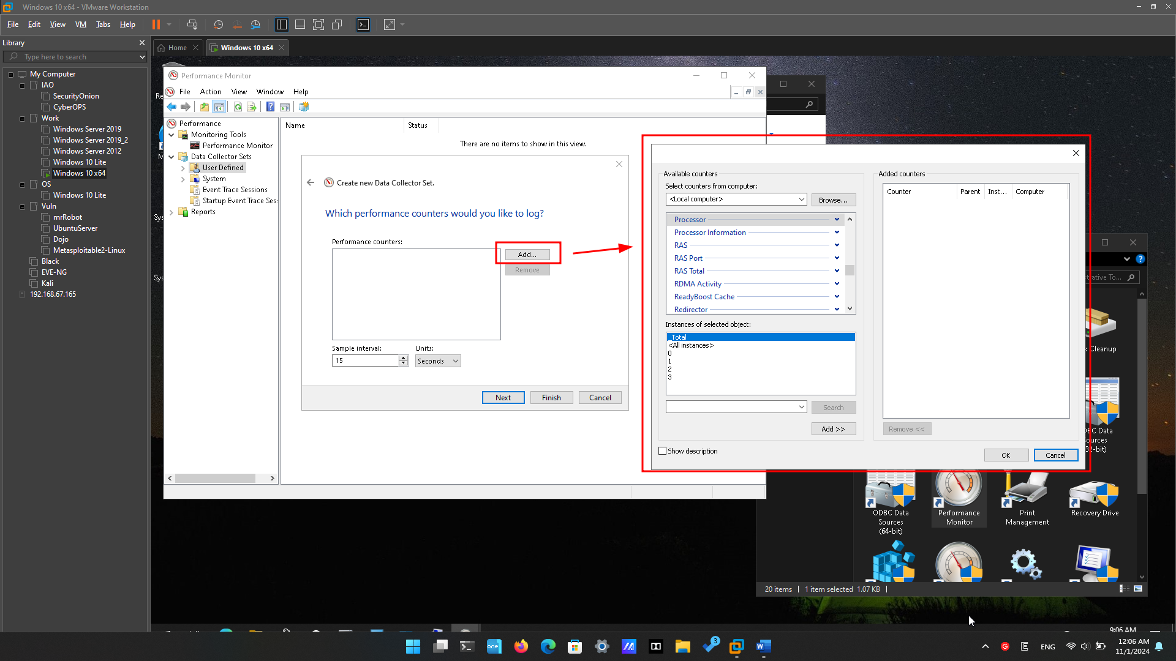

* + 1. From the list of available counters, locate and expand **Memory**. Select **Available MBytes** and click **Add>>**.

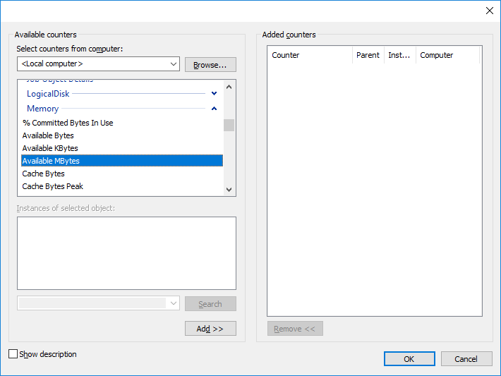

* + 1. You should see the **Available MBytes** counter added in the right pane. Click **OK**.

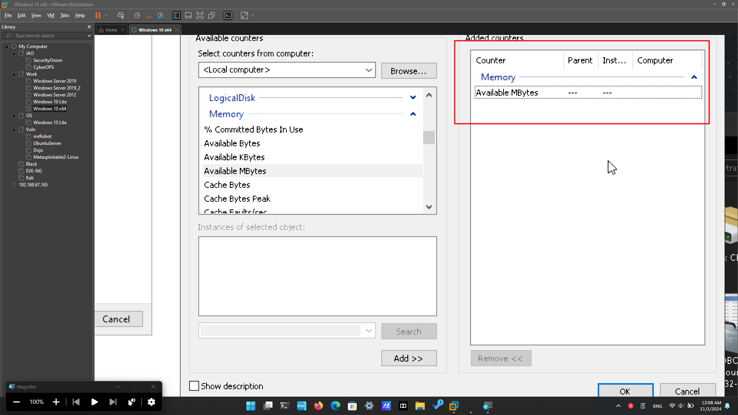

* + 1. Set the Sample interval field to **4** seconds. Click **Next**. 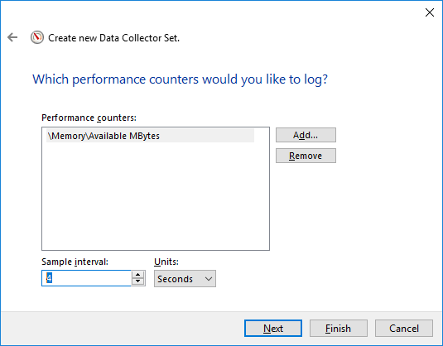
    2. In the **Where would you like the data to be saved?** screen, click **Browse**.
    3. In the **Browse For Folder** window , select your **(C:)** drive which is **Local Disk (C:)**. Select **PerfLogs** and click **OK**.

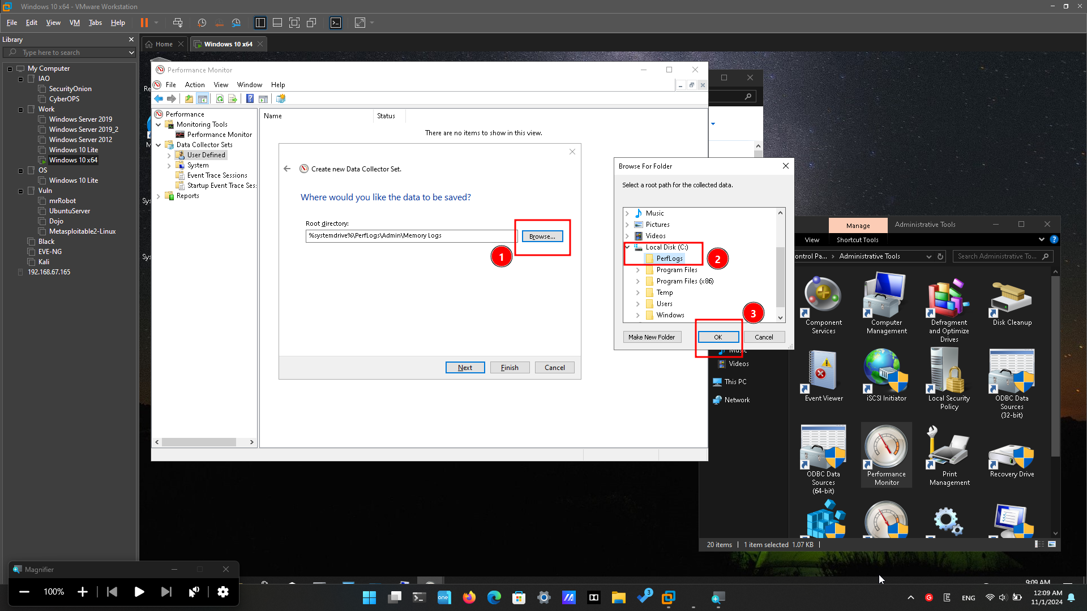

* + 1. The **Where would you like the data to be saved?** window opens with the directory information that you selected in the previous step. Click **Next**.
    2. In the **Create the data collector set?** screen, click **Finish**.
    3. Expand **User Defined** and select **Memory Logs.** Right-click **Data Collector01**and select **Properties**.

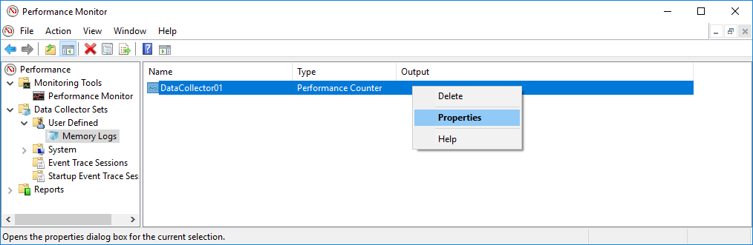

* + 1. In the **DataCollector01 Properties** window, chhange the **Log format:** field to **Comma Separated**.

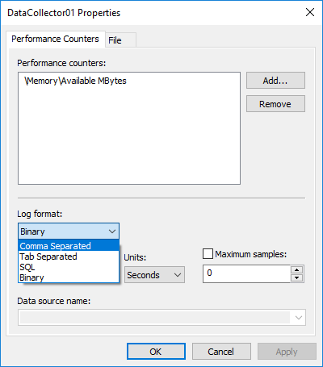

* + 1. Click the **File** tab.

What is the full path name to the example file?

C:\PerfLogs\DESKTOP-GU3MCH4_20240110-000001\DataCollector01.csv

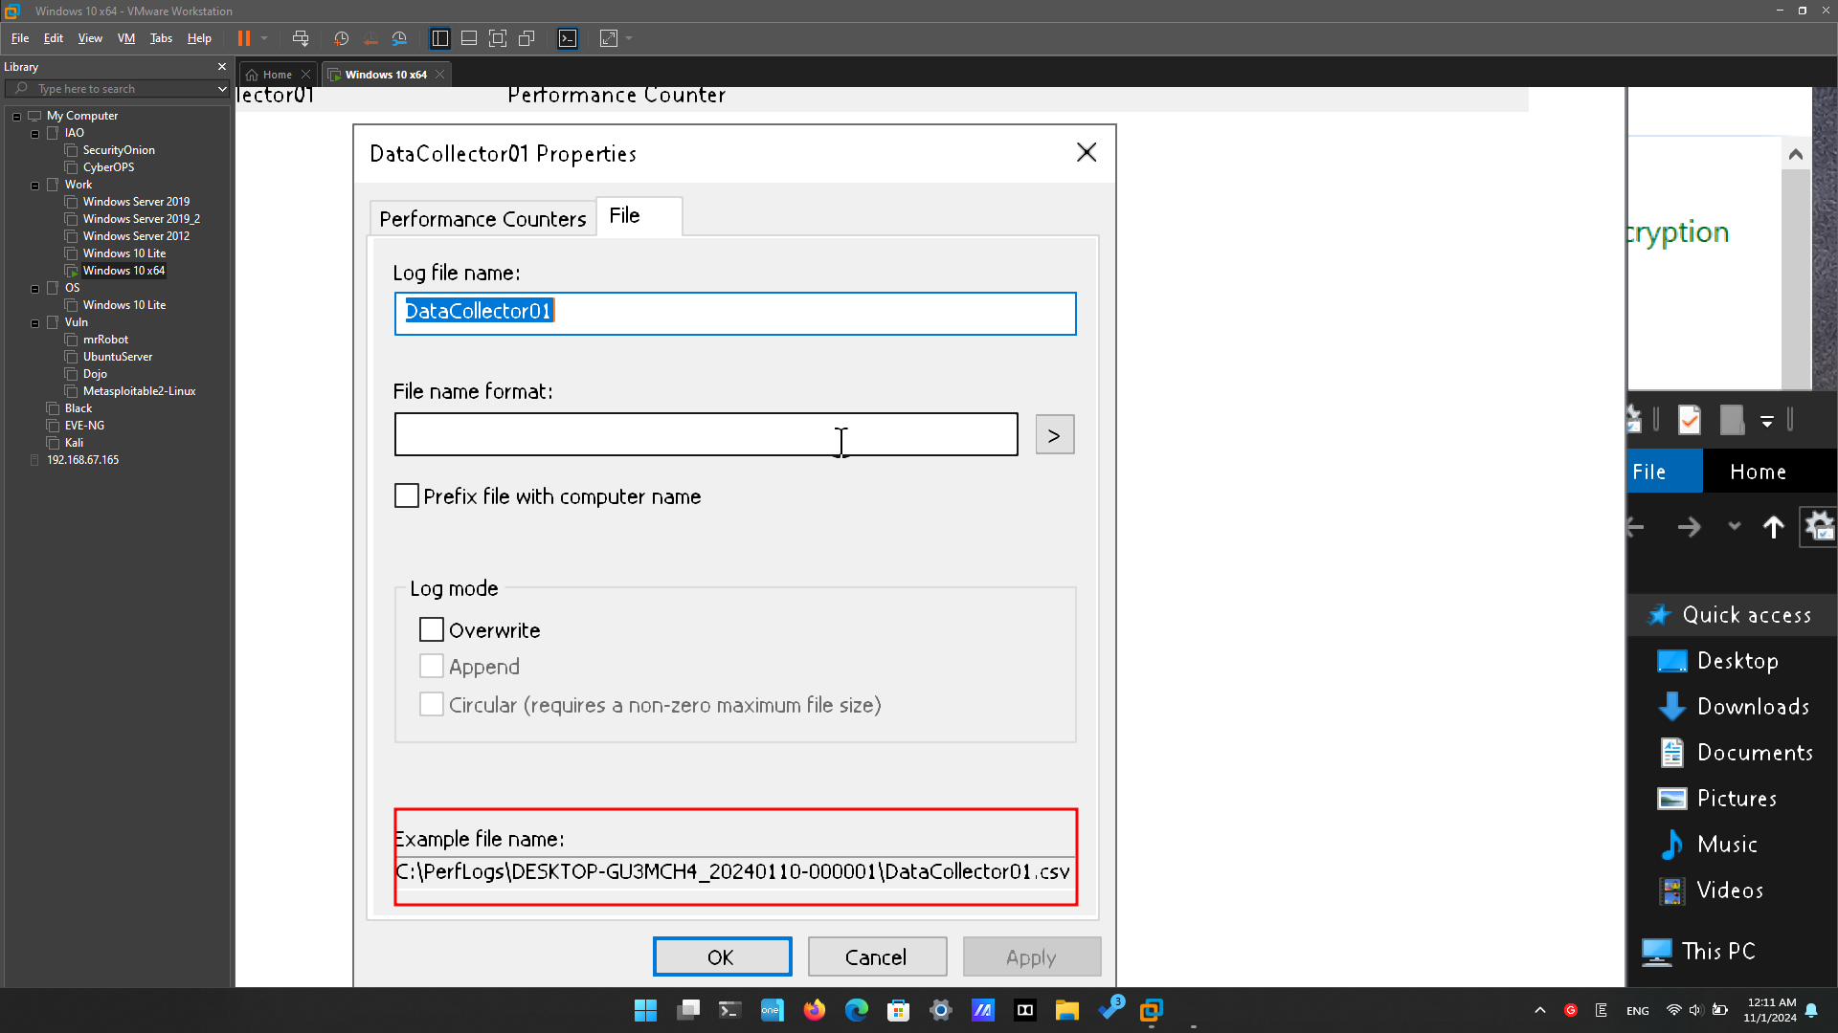

* + 1. Click **OK**.
    2. Select the **Memory Logs** icon in the left pane of the **Performance Monitor** window. Click the **green arrow** icon to start the data collection set. Notice a green arrow is placed on top of the **Memory Logs** icon.

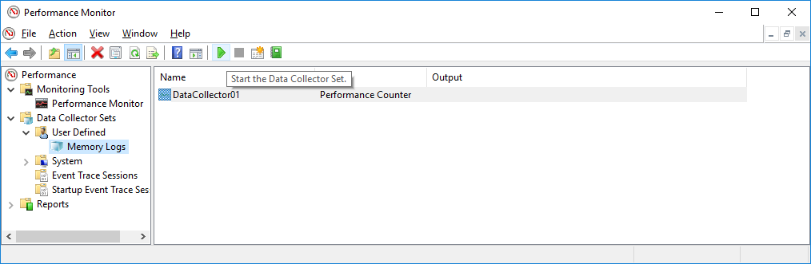

* + 1. To force the computer to use some of the available memory, open and close a browser.
    2. Click the **black square** icon to stop the data collection set.

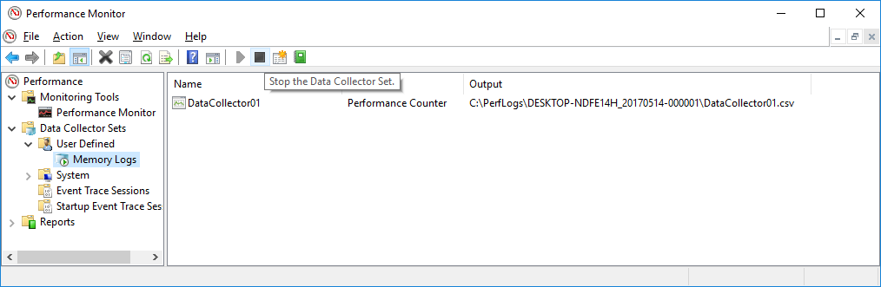

### Question:

What change do you notice for the Memory Logs icon?

The green arrow has been removed from the icon.

* + 1. Click **Start > Computer**,and click **drive C: > PerfLogs**. Locate the folder that starts with your PC’s name followed by a timestamp, **DESKTOP-NDFE14H_20170514-000001** in the example. Double-click the folder to open it, and then double-click the **DataCollector01.csv** file. **If prompted, click Continue to permit access to the folder.**

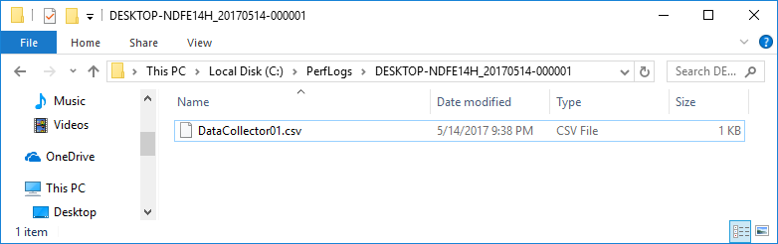

**Note**: If the **Windows cannot open the file**: message is displayed, select the radio button **Select a program from a list of installed programs** > **OK** > **Notepad** > **OK**.

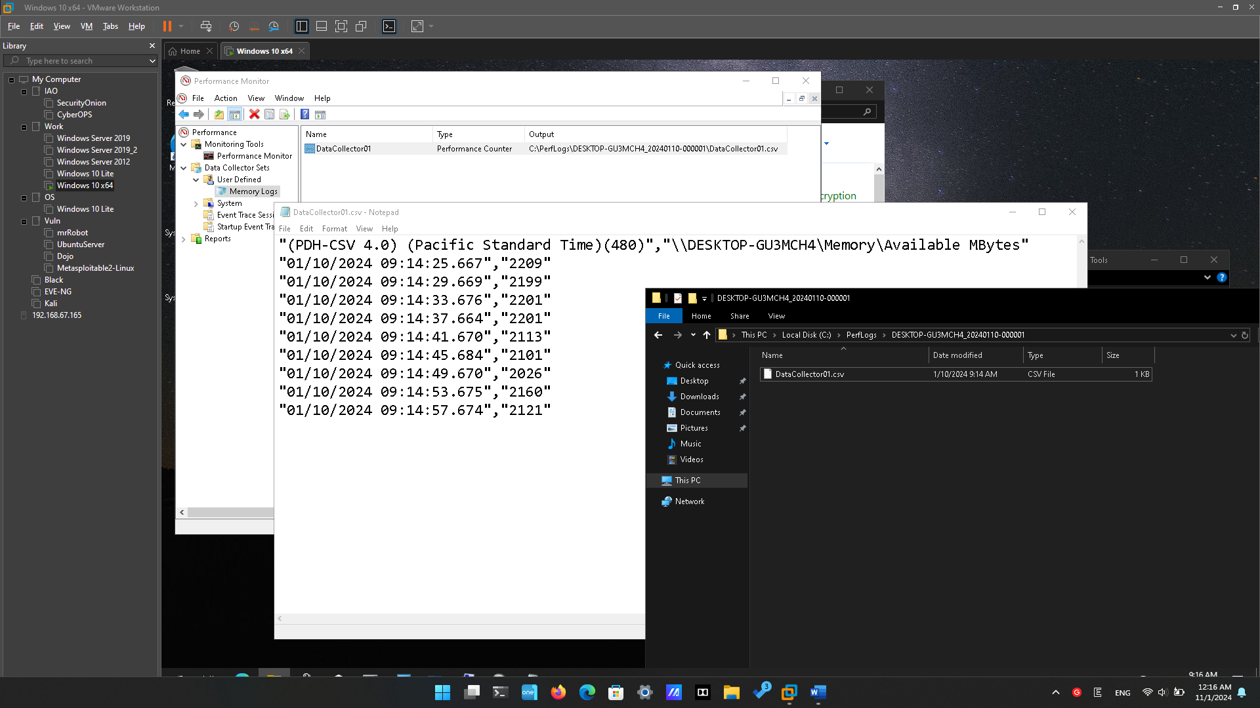

### Question:

What does the column farthest to the right show?

Available memory in MBytes.

* + 1. Close the **DataCollector01.csv** file and the window with the PerfLogs folder.
    2. Select the **Performance Monitor** window. Right-click **Memory Logs** > **Delete**.

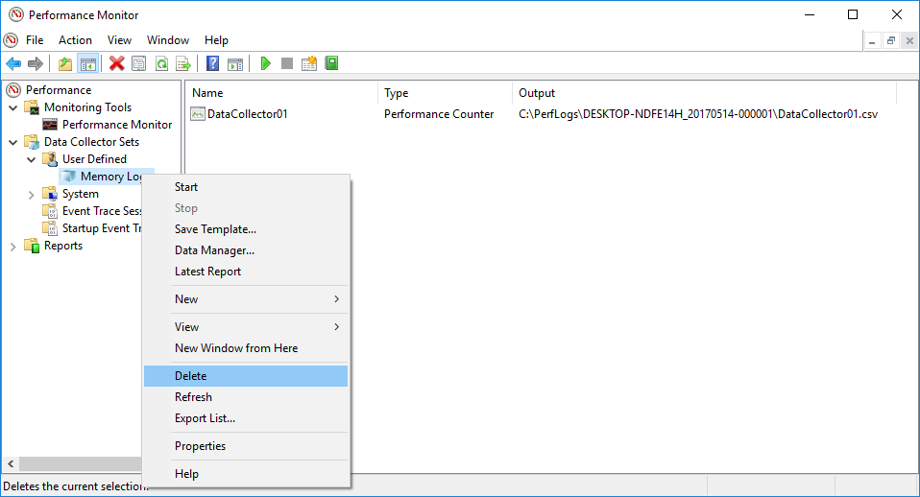

* + 1. The **Performance Monitor** > **Confirm Delete** window opens. Click **Yes**.
    2. Open drive **C: > PerfLogs** folder. Right-click on the folder that was created to hold the Memory log file, then click **Delete**.
    3. The Delete Folder window opens. Click **Yes**.
    4. Close all open windows.